
EN
European Economic and Social Committee

REPORT
SMEs – Trade development and investment environment opportunities
between the EU and Turkey

Rapporteur: Panagiotis GKOFAS (EL, GR. III)

General comments

Small and medium-sized enterprises (SMEs) represent the backbone of the European economy. The majority of SMEs are concentrated in the largest EU Member States (Italy, Spain, France, Germany, and the UK). These countries have more than 60% of the total number of SMEs as well as the share of total employment. They account for 99% of all businesses and provide 67% of all employment and almost 60 percent of the value added in the EU. In the European Union, there are around 24 530 000 SMEs (micro-: 22 830 900, small-: 1 420 700, medium-sized: 231 900). It is clear that the majority of SMEs in the European Union are micro-sized enterprises that employ less than ten persons. On the other hand, small and medium-sized enterprises (SMEs) constitute a major part of the Turkish economy. They make up 91.9% of all enterprises in Turkey, represent 78% of all employment and constitute 55% of GDP and 50% of total investment. In Turkey, there are 2 672 458 SMEs (micro-: 2 587 406, small-: 58 926, and medium-sized 26 126); see Figure 1 for more details.

Over the period 2008 to 2017, gross value added generated by EU-28 SMEs increased cumulatively by 14.3% and SME employment increased by 2.5%. Moreover, the internationalisation of SMEs has contributed to growth and the EU-28 SME exports of goods have increased by 20% since 2012. Employment in SMEs and value added grew rapidly in Turkey in the years 2009-2014; meanwhile employment in SMEs in the European Union slightly declined during the same period. Also, the value added of SMEs grew slightly or remained steady in the same period (but as a ratio of growth it is still way less than in Turkey) – see Figure 2 for more details –, even though new business registrations in Turkey in 2016 decreased by 7% compared to 2015. In entrepreneurship, Turkey's performance is better than the EU average; and its performance is comparable to the EU average for skills & innovation, environment, "responsive administration" and internationalisation. However, Turkey is still way behind the EU average in access to finance and "second chances" – see Figure 3 for more details. Giving entrepreneurs a second chance is not and established practice in Turkey. Moreover, access to finance is a big challenge for many SMEs.

SMEs in Turkey are more focused on wholesale & retail and manufacturing industries. Their contribution to employment and value added is much higher than in the EU (5 to 10 fold). SMEs in the accommodation and food services sectors in Turkey saw strong growth between 2010 and 2014. However, in recent years, the growth in these sectors and in tourism has declined due to the geopolitical tensions, terrorist attacks and the state of emergency following the attempted coup. However, the internationalisation of SMEs in Turkey appears to be less developed than in the EU, but it is still comparable to the average in the EU. Meanwhile, SMEs performance in selling products online is very weak in Turkey (2%) compared with the EU average of 17%. SMEs' R&D (Research & Development) and innovation capacity in Turkey is still less than in the EU and this area should therefore be promoted. Many SMEs in Europe offer goods or services that are specific to location, so it is not easy to internationalise them. In fact, 27% of non-exporting SMEs perceive their products or services being too specific to the domestic market as a major obstacle to exporting. SMEs with exporting experience can reduce the extent of most of the challenges they face (Figure 4). Therefore, the best way to address the challenge of internationalisation is by boosting SMEs' trade capacity. Where the customs union applies, tariffs and duties of course do not arise, but these can remain a serious problem betwee EU members and third countries in key areas, notably concerning a number of agricultural products, automobiles and ceramics. Therefore, ensuring free or easy movement of goods, services, as well as capital could be an opportunity to promote SMEs capacity to export and to internationalise. The lack of specialised staff and the different languages are also a barrier to internationalisation. A shortage of working capital and difficult access to external capital are perceived as key barriers to internationalisation for SMEs. Moreover, fulfilling orders and collecting payments abroad take longer. Often in Turkey, uncertainties, conflicts in a network, a profitable domestic market, the lack of experienced management involvement, a lack of ownership of marketed products, a lack of knowledge on marketing and fostering networks on the international stage are also key challenges for internationalisation.

Trade

The European Union is the world’s largest economic body and trading bloc, and it is ranked number one in both inbound and outbound international investments. In 2014, the EU's 28 Member States accounted for 16% of world imports and exports. Hence, the EU is a major pillar of the world’s economy. The EU utilised its capacity to create and implement trade agreements and still pursue free trade agreements with different partners across the globe. Turkey joined the GATT (General Agreement on Tariffs and Trade) in 1951, soon after its launch, and thus became a founder member of the WTO in 1995. Mutual trade interests between the EU and Turkey have been essential since the establishment of the European Economic Community (EEC) in 1958. In 1963, they signed the Ankara Agreement that aimed to accelerate mutual economic progress, expand trade relations, and reduce the disparity between Turkey and the EEC. Then, their trade relationship was fostered by the Customs Union agreement in 1995 that covers all industries, except (agriculture, services, and public procurement). Also, bilateral trade concessions apply to agricultural, coal and steel products between the EU and Turkey (preferential agreement on agriculture, 1996, and preferential agreement on coal and steel, 1998). Nevertheless, in December 2016, the EU Commission proposed to update the Customs Union to extend the bilateral trade relations to cover areas such as services, public procurement, and sustainable development. Add to the aforementioned, the fact that Turkey is a member of the Euro-Mediterranean (Euromed) partnership that aims to create a Euro-Mediterranean free trade area.

According to TURKONFED background information used during our preparatory works the "EU and Turkey face the mutual and diverse challenges of the 21st century: a rising trend of protectionism, transatlantic tensions, security threats and political instability in our common neighbourhood. Under these circumstances, the deepening of the Turkey’s economic integration to the EU through the modernisation and enhancement of the Customs Union should be recognised as a strategic goal rather than a short-term vision. Expansion of EU’s influence through a modernised Customs Union will have significant implications for the EU’s soft power in a turbulent period for international trade and create opportunities for the EU SMEs. Strong and innovative SMEs of the 21st century cannot flourish in a closed, fragmented and disconnected Europe. The Customs Union between the EU and Turkey needs to be modernised to cover currently lacking services, agriculture, public procurement and to provide a symmetric dispute settlement mechanism. European businesses will be able to enjoy improved market access in these sectors, particularly in services, where there are untapped opportunities for EU SMEs according to the study by the European Commission. In addition to the direct mutual benefits and potential of fostering competitiveness, upscaling, enhanced trading relations, and internationalisation of SMEs, the promotion of environmental and other European standards along with the spill-over effects of technology and know-how will be mutually valuable. Digitalisation offers a great opportunity for SMEs which can promote Turkey's integration to the EU’s digital single market."

Accordingly, the EU is Turkey's largest trade partner (two out of five goods traded by Turkey come from or go to the EU); and Turkey is the EUs fifth largest trade partner. Turkey is the EU's fourth largest export market, and fifth largest provider of imports. Around 44.5% of Turkey's export go to the EU and its other main export markets are Iraq, USA, Switzerland, United Arab Emirates and Iran. Its main imports come from the EU (38%), and these key markets: China, Russia, USA, South Korea and Iran. The main EU exports to Turkey are machinery, transport material, chemical products and manufactured goods; while Turkey's exports to the EU are mostly machinery, transport equipment, followed by manufactured goods – see Figure 5 for more details about the export and import of goods between the EU and Turkey. In goods, EU exports more to Turkey than its imports from it; but in services, Turkey exports to EU more than it imports from it. This is maybe due to the fact that Turkey has experienced good investments in IT & technology call centres, and data collection centres, as well as consulting and financial services. In total, EU exports to Turkey are more than its imports from it. The main export and import partners of Turkey in the EU are Denmark, Italy, the UK, and France (Figure 6).

Investments & Finance.

The EU is Turkey's largest source of foreign direct investment (over 70% of FDI in Turkey originates in the EU). In a period of global financial instability, the EU remained the main investment partner for Turkey and accounted for about two-thirds of FDI inflows to Turkey between 2008 and 2015. By the end of 2015, there were 20 585 companies operating in Turkey with capital from the EU (43.6% of all companies established by foreign capital in the country). The EU inward stocks from Turkey way less than the EU outward stocks in Turkey. However, FDI (foreign direct investment) flows from the EU into Turkey dropped sharply from a historic high of EUR 11.9 bn in 2015 to EUR 0.3 bn in 2016 due to the political due to the geopolitical tensions, terrorist attacks and the state of emergency following the attempted coup.

The EU has an essential role in boosting Turkey’s economy by focusing on its economic backbone (SMEs). The EU has supported many projects that facilitated financial access for SMEs in areas such as fashion and the textile industry; and in supporting commercial chambers and business parks, particularly in less-developed areas. In addition, measures were applied to underpin commercial activity through strengthening intellectual and industrial property rights as well as the quality of infrastructure. Reducing trade barriers, improving transportation links, information technologies and the emergence of global value chains (GVC) have been helping many SMEs gain the potential to become successful global traders. There is still a large gap in SMEs' exporting activity in the industrial sector. Moreover, despite SMEs making a great contribution to national economies, they are still underrepresented in global trade (Figure 7). Despite this, SMEs account for a larger share of value added in international trade when indirect exports are taken into account. SMEs' participation in trade has an important role in helping them to grow and be more productive. Turkey applied the Law on project-based investment incentives in September 2016. This law provided tax exemptions, customs duty exemptions, free land allocation, social security premium supports, compensation of up to 50% for energy expenses and interest rate subsidies. For an investment to benefit from these incentives, it has to meet at least one of the following criteria: conformity with Turkey's national development plan, be R&D (Research & Development) focused, innovative, technology-oriented, high value added, and aim to reduce Turkey’s external dependence. However, European SMEs still feel a bit discriminated against by this law.

Some progress in trade and investment was made in the energy sector, particularly in the gas market, and in increasing R&D spending. Turkey's trade and economic integration with the EU is high and increased further in 2016 and 2017. However, significant problems still are in place with regard to the quality of education and professional education quality should therefore be improved on, including qualifications for low-skilled workers through training, and increased R&D capacity. There are some technical barriers to trade preventing the free movement of goods and localisation schemes and domestic requirements discriminate against EU products, violating Turkey’s obligations under the Customs Union. Free movement of capital in Turkey is still less than in the EU, and Turkey should fight more against money laundering and terrorist financing. Despite this, Turkey is moderately prepared in the area of public administration reform and it has a made a firm commitment to having a more open administration and to more use of e-government. Turkey is at a good level of preparation for the free movement of goods. It also made some progress in aligning with the "New and Global Approach" EU acquis and market surveillance. EU-Turkey SMEs representative intermediaries’ platforms have been promoted with academic and non/academic networks to tackle major trade issues, as well as new areas of collaboration such as natural disaster risk mitigation platforms (pilot programmes, capacity building project and observatories).

In 2017, the Turkish Exporters' Assembly signed an agreement with the e-commerce platforms Alibaba and Kompass, which is expected to foster SMEs' participation in global e-commerce markets and create opportunities for new entrants. For further trade and investment between the EU and Turkey, investments in the following fields are great bilateral opportunities for SMEs. Quality of education, R&D, IT & technology, call centres and data collection centres, and fibre communication infrastructure, cosmetics, healthcare, plastic surgery and hair transplants, etc., renewable energy, environmental investments, and services such as consultancy, e-commerce, marketing and financing. There is also the manufacturing sector, including manufacturing and construction investments that could not be completed due to a lack of working capital. Therefore, the EU and Turkey should establish approaches to addressing constraints faced by SMEs when internationalising, including access to information, skills, technology, and finance, as well as trade facilitation and connectivity.

Recommendations

An agreement that includes these crucial aspects of 21st century trade agreements will also feed into the broader process of Turkey's integration with the EU, by strengthening democratic economic governance in Turkey, and result in positive economic convergence. In order to achieve the goal of maximising the benefits of this process for the EU and Turkish citizens, key bottlenecks in SME trade need to be addressed:

- Take the specific needs of the SMEs into account in a dedicated SME chapter, periodical harmonisation and acquisition of data on SMEs in trade and the investment environment for EU- Turkey bilateral relations.
- Develop specific SME access to finance instruments addressing the new challenges stemming from a modernised Customs Union agreement;
- Apply "think small first principles "and an SME-oriented policy & programmes impact analysis.

In order to make this deal a functioning one, we need to address the visa issue, which creates a major NTB to trade, especially for SMEs.

*

* *

N.B.: Appendix over leaf.

Appendix
Figure 1.
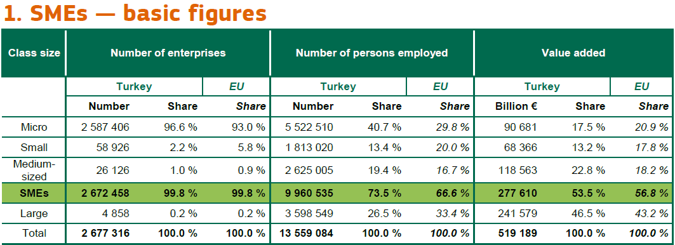
Source: https://ec.europa.eu/neighbourhood-enlargement/sites/near/files/turkey_sba_fs_2017.pdf

Figure 2.
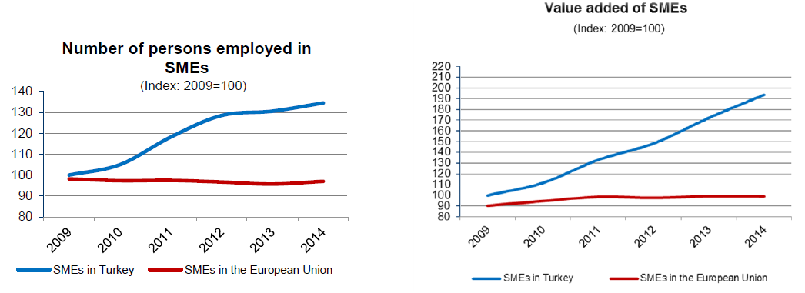
Source: https://ec.europa.eu/neighbourhood-enlargement/sites/near/files/turkey_sba_fs_2017.pdf

Figure 3.
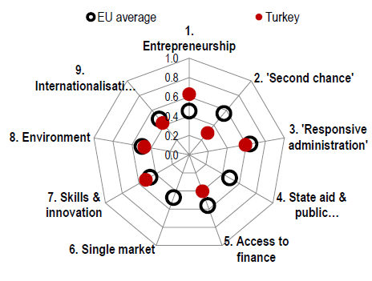
Source: https://ec.europa.eu/neighbourhood-enlargement/sites/near/files/turkey_sba_fs_2017.pdf

Figure 4.
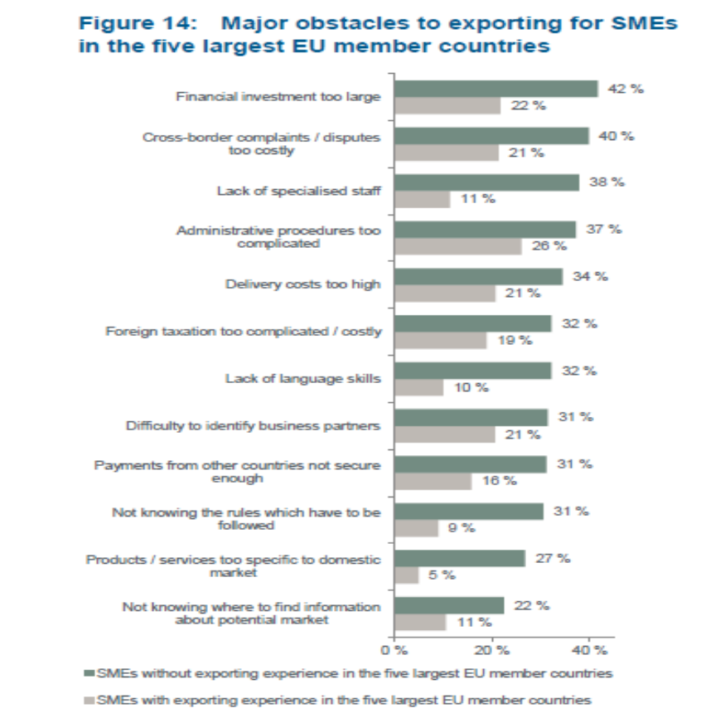
Source: https://www.kfw.de/PDF/Download-Center/Konzernthemen/Research/PDF-Dokumente-Studien-und-Materialien/Internationalisation-of-European-SMEs.pdf

Figure 5.
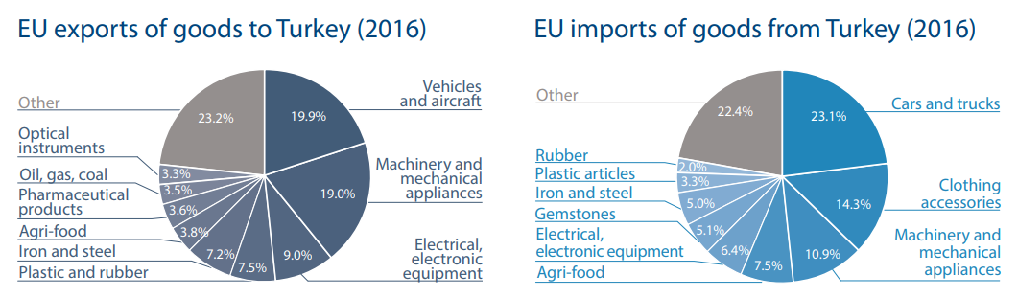
Source: http://www.europarl.europa.eu/RegData/etudes/ATAG/2017/603912/EPRS_ATA(2017)603912_EN.pdf

Figure 6.
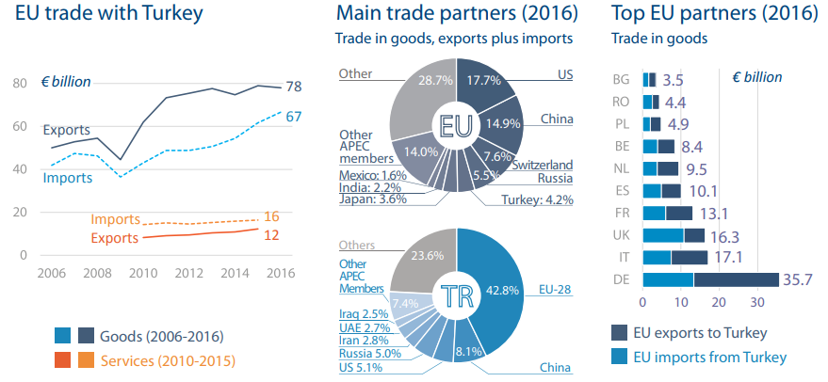
Source: http://www.europarl.europa.eu/RegData/etudes/ATAG/2017/603912/EPRS_ATA(2017)603912_EN.pdf

Figure 7.
Compared to their contributions to national economies, SMEs are underrepresented in global trade.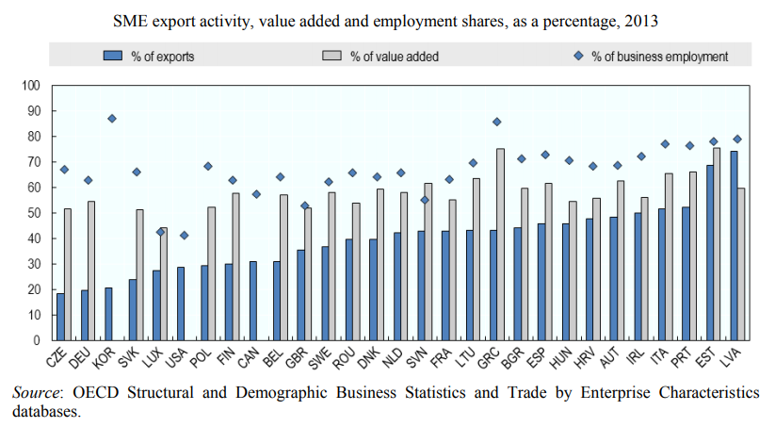
Source: https://www.oecd.org/cfe/smes/ministerial/documents/2018-SME-Ministerial-Conference-Plenary-Session-3.pdf

_____________

SPON: Inspire Policy Making by Territorial Evidence: https://www.espon.eu/sites/default/files/attachments/Small%20and%20Medium-sized%20Enterprises%20in%20European%20Regions%20and%20Cities.pdf
Statista - https://www.statista.com/statistics/878412/number-of-smes-in-europe-by-size/
Sıdıka Başçı and Ayşegül Durucan: A Review of Small and Medium Sized Enterprises (SMEs) in Turkey; https://www.researchgate.net/publication/322437518_A_Review_of_Small_and_Medium_Sized_Enterprises_SMEs_in_Turkey
2017 SBA Fact Sheet Turkey - European commission: https://ec.europa.eu/neighbourhood-enlargement/sites/near/files/turkey_sba_fs_2017.pdf
DIW ECON, February 2018: https://diw-econ.de/en/publications/studies/annual-report-on-european-smes-2017-2018/
2017 SBA Fact Sheet Turkey - European commission: https://ec.europa.eu/neighbourhood-enlargement/sites/near/files/turkey_sba_fs_2017.pdf
2017 SBA Fact Sheet Turkey - European commission: https://ec.europa.eu/neighbourhood-enlargement/sites/near/files/turkey_sba_fs_2017.pdf
2017 SBA Fact Sheet Turkey - European commission: https://ec.europa.eu/neighbourhood-enlargement/sites/near/files/turkey_sba_fs_2017.pdf; This area can be improved by the EU businesses, as they have more experience in this field.
Internationalisation of European SMEs – Taking Stock and Moving Ahead: https://www.kfw.de/PDF/Download-Center/Konzernthemen/Research/PDF-Dokumente-Studien-und-Materialien/Internationalisation-of-European-SMEs.pdf
Internationalisation of European SMEs – Taking Stock and Moving Ahead: https://www.kfw.de/PDF/Download-Center/Konzernthemen/Research/PDF-Dokumente-Studien-und-Materialien/Internationalisation-of-European-SMEs.pdf
Müjdelen Yenera, Barış Doğruoğlub and Sinem Ergunb: Challenges of Internationalization for SMEs and Overcoming these Challenges: A case study from Turkey: https://www.sciencedirect.com/science/article/pii/S1877042814050514
The EU as an Essential Economic Partner for Turkey: https://www.avrupa.info.tr/en/eu-essential-economic-partner-turkey-47
However, processed agricultural products are covered by the Customs Union between the EU and Turkey.
European Commission, 2018; https://ec.europa.eu/neighbourhood-enlargement/sites/near/files/20180417-turkey-report.pdf
European Commission; http://ec.europa.eu/trade/policy/countries-and-regions/countries/turkey/
European Commission; http://ec.europa.eu/trade/policy/countries-and-regions/countries/turkey/
European Union, Trade with Turkey - Total goods: EU Trade flows and balance, annual data 2007 - 2017; https://webgate.ec.europa.eu/isdb_results/factsheets/country/details_turkey_en.pdf
European Commission, 2018; https://ec.europa.eu/neighbourhood-enlargement/sites/near/files/20180417-turkey-report.pdf
European Commission 2018; https://ec.europa.eu/neighbourhood-enlargement/sites/near/files/20180417-turkey-report.pdf
See also the study by Montalbano, Nenci and Pietrobelli, 2017: their results prove that there is a positive relationship between participation in international activities and firm performance; both participation in GVCs and position within GVCs matter. Therefore, policymakers should seek to enhance the link between GVCs’ integration and firms’ productivity; https://link.springer.com/article/10.1007/s11187-017-9902-6
OECD: SME Ministerial Conference, Fostering greater SME participation in a globally integrated economy; https://www.oecd.org/cfe/smes/ministerial/documents/2018-SME-Ministerial-Conference-Plenary-Session-3.pdf
2017 SBA Fact Sheet Turkey - European commission: https://ec.europa.eu/neighbourhood-enlargement/sites/near/files/turkey_sba_fs_2017.pdf

